README

<?xml version="1.0"?><DocumentBlank xmlns:xsi="http://www.w3.org/2001/XMLSchema-instance" xmlns:xsd="http://www.w3.org/2001/XMLSchema"> <GraphicCharterDefinitionId>0</GraphicCharterDefinitionId> <TemplateBaseTypeId>0</TemplateBaseTypeId> <CompanyId>2</CompanyId> <ConfidentialId>0</ConfidentialId> <ConfidentialDescription /> <CountryId>0</CountryId> <PageSizeId>1</PageSizeId> <PageOrientationId>1</PageOrientationId> <PrePrintedStationary>false</PrePrintedStationary> <Project>readme</Project> <Reference>20150812-110859-DT</Reference> <TemplateType>1</TemplateType> <CultureId>en-US</CultureId> <LanguageId>8</LanguageId> <Customer>NPA</Customer> <DocumentDate>2016-07-12T17:57:59.1025166+05:30</DocumentDate> <Saved>false</Saved> <IsValid>true</IsValid> <FirstPageCover>false</FirstPageCover> <IsNew>false</IsNew> <FirstPageHeader /> <FirstPageSubHeader /> <Title>README</Title></DocumentBlank>

|  |  |  |  |  |
| --- | --- | --- | --- | --- |
|  |  |  |  | |
|  |  |  |  | |
|  |  | INC0199922 and INC0199923 | | |
|  |  |  | | |
|  |  | Version 1.0 of Friday, December 16, 2016 | | |
|  |  |  | |  |

To

|  |  |
| --- | --- |
|  |  |

Document History

|  |  |  |  |  |
| --- | --- | --- | --- | --- |
| **Version** | **Date** | **Update Origin** | **Written by** | **Verified by** |
| 1.00 | 15/12/2016 | Creation | Shikha Bansal |  |
|  |  |  |  |  |
|  |  |  |  |  |

Summary

1. Introduction 4

2. Prerequisite 4

3. Steps 4

4. Validation 9

5. Rollback 9

# Introduction

The purpose of this document is to fix the issues mentioned in the incidents INC0199922 and INC0199923

# Prerequisite

1. Take backup of bdocs (M508_01_plat, Message508_01_conv_plat_vers_xml_out and Message508_01)

# Steps

* **Change in map broker 3_2_conversion_508_01_plat_vers_xml**

1. Change in mapping of all fields mentioned below.

getSubString( in:\Sinistres_Hors_Auto\Enreg100\ENTDATMSG,7,2) &getSubString( in:\Sinistres_Hors_Auto\Enreg100\ENTDATMSG,5,2) &getSubString( in:\Sinistres_Hors_Auto\Enreg100\ENTDATMSG,1,4)

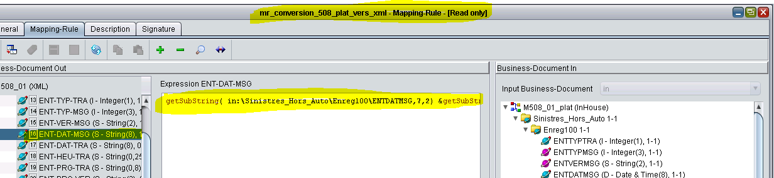

**NOTE: Replace the above highlighted field name by the name of the field for which we are applying the changes.

ENTDATMSG ENTDATFIN

MSGDATSIN

1. Change in mapping in the ENT-DAT-TRA and ENT-DAT-DEB fields and write in expression.

if not isNullOrAbsent(in:\Sinistres_Hors_Auto\Enreg100\ENTDATTRA)

then

getSubString( in:\Sinistres_Hors_Auto\Enreg100\ENTDATTRA,7,2) &getSubString( in:\Sinistres_Hors_Auto\Enreg100\ENTDATTRA,5,2) &getSubString(in:\Sinistres_Hors_Auto\Enreg100\ENTDATTRA,1,4)

else absent

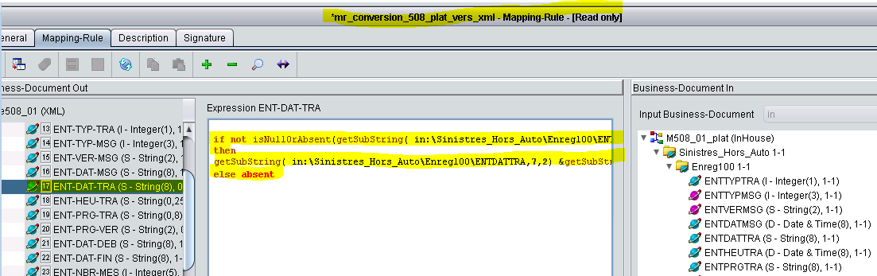

**NOTE: Replace the above highlighted field name by ENT-DAT-DEB field for which we are applying the changes.

1. Change the mapping of all the fields mentioned below.

if not isNullOrAbsent( getSubString( in:MSGOUVCOU,7,2) &getSubString( in:MSGOUVCOU,5,2) &getSubString( in:MSGOUVCOU,1,4))

then

getSubString( in:MSGOUVCOU,7,2) &getSubString( in:MSGOUVCOU,5,2) &getSubString( in:MSGOUVCOU,1,4)

else absent

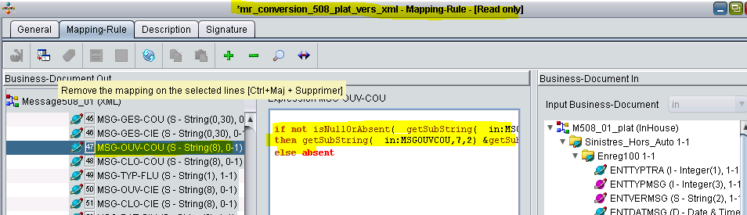

**NOTE: Replace the above highlighted field name by the name of the field for which we are applying the changes.

MSGOUVCOU MSGCLOCOU

MSGOUVCIE MSGCLOCIE

MSGPERCON MSGDATPRE

MSGDATSUB

1. Change the mapping of the fields mentioned below.

%tempvar := trimString( in:Sequence[%j]\MSGEVACIE ,"0" );

if not isNullOrAbsent( %tempvar ) and %tempvar <> ""

then

formatString(in:Sequence[%j]\MSGEVACIE,"S000000000000000")

else absent

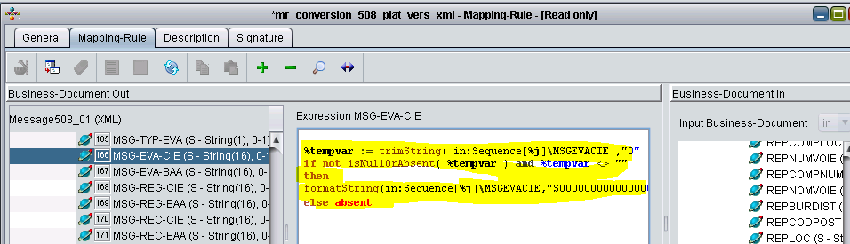

**NOTE: Replace the above highlighted field name by the name of the field for which we are applying the changes.

MSGEVACIE MSGEVABAA

MSGREGCIE MSGREGBAA

MSGRECCIE MSGRECBAA

MSGMNTFRA

* **Change in map broker 3_2_conversion_508_01_xml_vers_plat**

1. Change the mapping of the fields mentioned below.

convertToD(getSubString( in:!ENT-DAT-MSG!,5,4)&getSubString( in:!ENT-DAT-MSG!,3,2 )&getSubString( in:!ENT-DAT-MSG!,1,2 ),"YYYYMMDD")

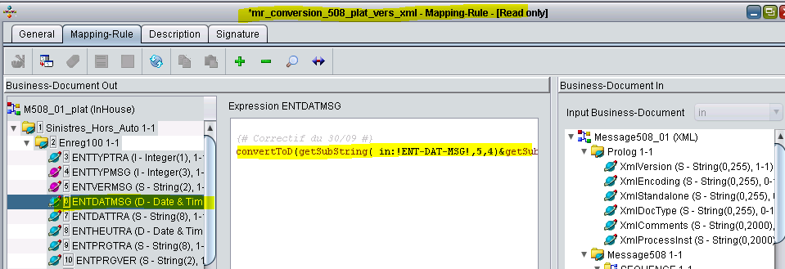

**NOTE: Replace the above highlighted field name by the name of the field for which we are applying the changes.

ENTDATMSG ENTDATFIN

MSGDATSIN ENTDATDEB

1. Change the mapping of ENT-DAT-TRA field as mentioned below.

if not isNullOrAbsent( in:\Message508\Enreg100\!ENT-DAT-TRA! )

then

{

getSubString( in:!ENT-DAT-TRA!,5,4) & getSubString( in:!ENT-DAT-TRA!,3,2 ) & getSubString( in:!ENT-DAT-TRA!,1,2 )

}

else absent

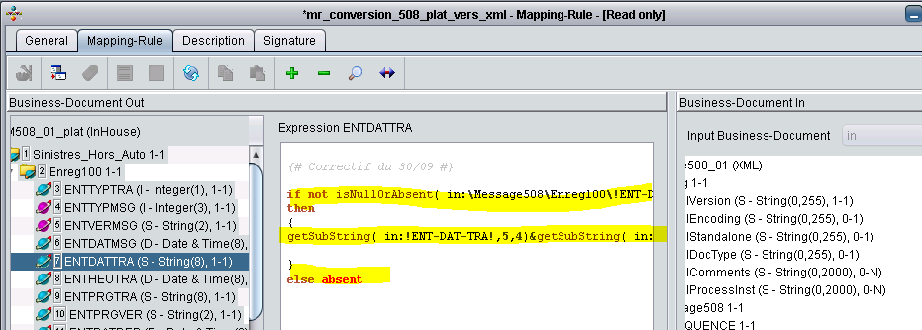

1. Change the mapping of the fields mentioned below.

if not isNullOrAbsent( in:!MSG-CLO-COU! )

then

{

getSubString( in:!MSG-CLO-COU!,5,4 ) & getSubString( in:!MSG-CLO-COU!,3,2 ) & getSubString( in:!MSG-CLO-COU!,1,2 )

}

else absent

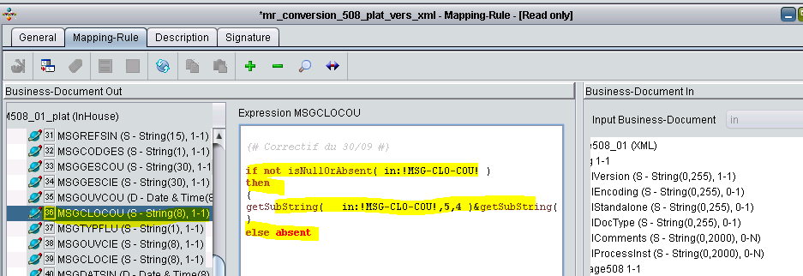

**NOTE: Replace the above highlighted field name by the name of the field for which we are applying the changes.

MSG-CLO-COU MSG-OUV-CIE

MSG-CLO-CIE MSG-PER-CON

MSG-DAT-PRE

1. Change the mapping of the fields mentioned below.

if not isNullOrAbsent( in:!MSG-DAT-SUB! )

then

{

%resultat:=getSubString( in:!MSG-DAT-SUB!,5,4 )&getSubString(in:!MSG-DAT-SUB!,3,2 )&getSubString(in:!MSG-DAT-SUB!,1,2 );

%Date:=convertToD(%resultat, "YYYYMMDD")

}

else %Date:= absent

;

%Date

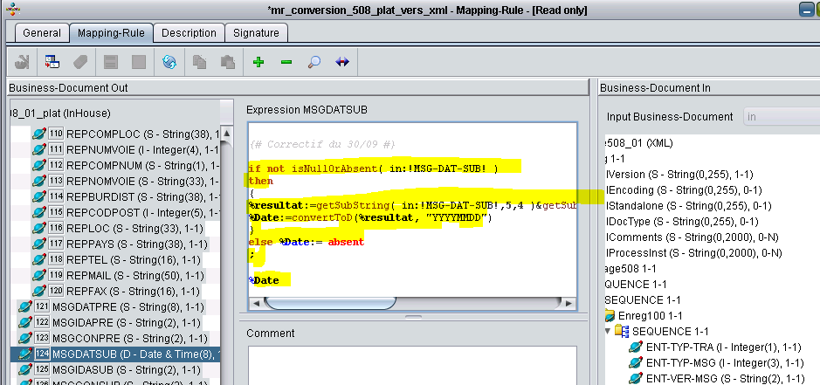

**NOTE: Replace the above highlighted field name by the name of the field for which we are applying the changes.

MSG-DAT-SUB MSG-DAT-SIN

# Validation









# Rollback

We can revert the changes from the backup steps performed during prerequisite.